*OMNIPRENEURSHIP*

*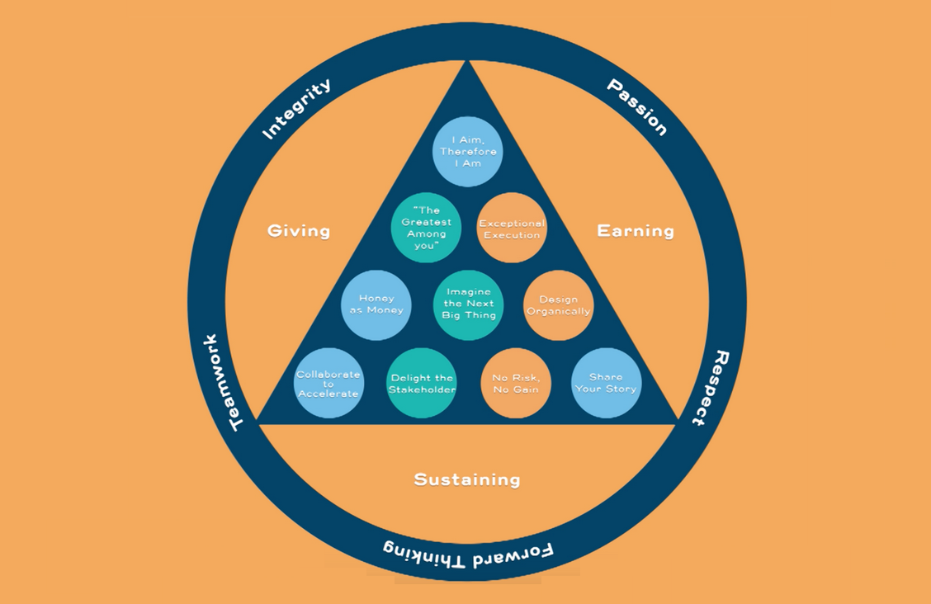*

*A PAPER PRESENTED AT A WORKSHOP/ INDUCTION*

*FOR CERTIFIED MEMBERS OF THE CHARTERED INSTITUTE OF GLOBAL COMMUNICATONS AND DIPLOMACY NIGERIA ON THE 7TH MAY 2016 AT MERIT HOUSE ABUJA NIGERIA.*

*BY*

*Agrih Dauda Sukukum*  **(**Fcigcd) (Mcipma-USA) (Mnipr) (CPT) NCE, HND,PGD,MBA.

## Global Social Entrepreneur.

## Public Relations consultant

## MAY 7TH, 2016.

## Content : 1. What is omnipreneurship. 2. The 5 principles and values. 3.Ten Golden Rules for Impact and Meaning .4 personification. 5. leadership. .6.Problem solving skills. 7. Meetings. 8.micro metrics of corruption. The 5 ps. Conclusion.

## Aim of this Paper; *As in line with the 5th principles of the institute on”On creative Entrpreneurship”*

## Objectives. To enable you know Why things don’t work some times in our plans. 3. To enable you Know how to manage one self and maintain reputation and maximize your potentials. any where. 4.To Know the Ten golden rules for managing yourself or your ventures 5 To,. Know how to solve problems. To Plan your Actions and activities for a specific period.

## .Goals: Reaching your Goals as a Chartered professional member of the chartered institute of global communications and diplomacy and stand out as a leader.p 1: Read the Assigned Readings

### Step 1: be attentive.

Listen to the following lecture to learn about a new leadership framework through the lens of Principles, Values, and the Ten Golden Rules. you will use the guiding questions below to self-assess your understanding.

**Step 2. Guiding Questions:**

1. What are good examples of principles and values you've seen exhibited by you and other organizations?
2. How are principles different from values?
3. What areas of your organization could benefit from the application of the Ten Golden Rules?
4. What do you think people expect from you, as a professional global communicator and diplomat.?
5. Can you solve basic problems? And identify areas of great concern to your self and to the society or community in which you live.

[Principles](https://novoed.com/philanthropy-university-leadership/video_list_lecture_components/757792/lecture_videos/19333)[Values & the Ten Golden Rules](https://novoed.com/philanthropy-university-leadership/video_list_lecture_components/757792/lecture_videos/19334)

Progress: 0.0%

1. Think about some of your favorite organizations in the social or private sector. Do they have a specific set of Principles or Values that are particularly powerful? identify one of your favorite sets of Principles and Values, and explain in 2-3 sentences why you think they are a strong example.
2. Draft your own set of Principles or Values for yourself personally or your organization (if you belong to one): create a visual representation of your Principles or Values by using Amr's [visual representation](https://novoed.com/philanthropy-university-leadership/attachments/85348/view) as a model See fig 1.

3. Complete your Omnipreneurship life plan. See Fig 2.

**What Is Omnipreneurship? 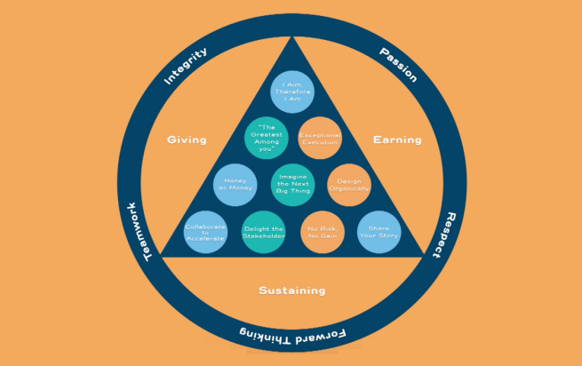**

Developed over the past 30 years, omnipreneurship is an approach to building a meaningful life. It comprises three principles, five values, and ten “golden rules” that apply equally to every realm of activity, whether you are operating in business, the public sector, the nonprofit world, your family, or your own personal world. With omnipreneurship, you can achieve meaning across all the arenas of your life.

Why do I call this approach “omnipreneurship”? Though I passionately believe in the fundamentals of entrepreneurship—starting something, gathering the resources to make it grow, and being responsible for its su has been hijacked. It’s been devalued by an ever-narrowing definition that focuses on starting an innovative business and quickly harvesting personal profit. It’s become much too narrow a concept to meet the needs and challenges of the world today.

Omnipreneurship is a much larger, more encompassing concept. Developed by Amr AL Dabbagh.

He said ‘Think of what we most admire in leaders who are paradigm-breakers —people like Steve Jobs, Elon Musk, Mark Zuckerberg, and Richard Branson. These are disruptive innovators who invert existing paradigms, delight whole new worlds of customers, and even open up new industries. And they have a set of admirable characteristics—pluck, competitiveness, a willingness to take risks, imagination, hunger, creativity, and, most importantly, vision. What if we released that spirit of **entrepeneurship** from its shackles and applied all those admirable characteristics in a much bigger way to everything we do?

What if, instead of just having entrepreneurs concerned only with business, we had a world full of “governpreneurs” who applied their great entrepreneurial skills to public policy; 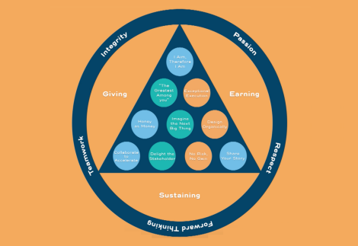 “**philanthropreneurs**” who did the same with charitable organizations; “**familypreneurs**” who looked for new ways to support their families; and even **individual “preneurs**” who applied a set of the best entrepreneurial characteristics to the ways they conduct themselves in their own lives and careers? The omnipreneur is someone who can master “preneurship” in all aspects of life, though not necessarily immediately or simultaneously.

## Omnipreneurship extends “preneurship” in several new directions at once. I believe that the strategies and skills needed to accelerate success and live a life of meaning should belong to everyone—not just people in business, but also workers in public secto and private sector, excess— that is the term “entrepreneurship” A concept. Is Omnipreneurship going to Work for me?

## The Principles, Values and the Ten Golden Rules

****

**FIG 1 .**

**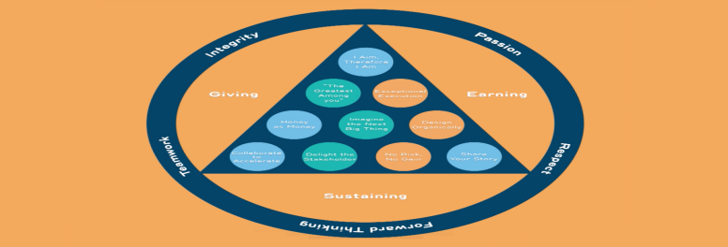**

**Chapter 1: Introduction \***

*The search for meaning; a definition of “omnipreneurship”; why entrepreneurship needs rethinking; why omnipreneurship works;introduction to the three principles, five values, and ten “golden rules”; what you will learn in this Workshop.*

**Chapter 2: The Three Interlocking Principles:**

* **Giving,**
* **Earning,**
* **and Sustaining **

***Giving*:** Giving is the purpose of life. I believe it gives meaning to our existence here on earth. We give our compassion and respect to others. We give resources, time, and money as we are able. Giving is love.

***Earning*:** Earning is energy. Earning is about gathering the fuel and resources we need to thrive. Earning is exhilarating. When we earn knowledge, reputation, respect, partnership, and wealth, we are stoking our fire and the fire of our community.

***Sustaining*:** Sustaining is about investing in those who will carry the torch. It is informed by what we call “sustainability,” the care of our resources and our planet.

“Sustain” is a verb that helps me focus on all 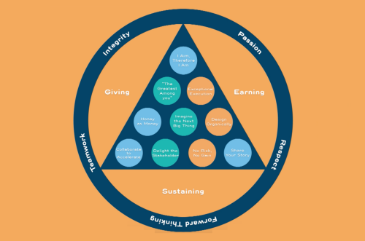the stakeholders—my family, my colleagues, my children, the NGOs we support, and the world’s children, who hold the promise for a brighter future.

By giving, earning, and sustaining, you can achieve both the perfect balance and the ongoing energy you need to make your dreams come to life. People sometimes challenge me to a debate over what forms giving, earning, and sustaining should take, given that company’s businesses are part of the for-profit world. We grow and distribute food; we work with petroleum-based products; you provide housing to people- and to development-based companies.

Some might ask whether you can really contribute to the balance of giving, earning, and sustaining. Your job as a professional is to grow businesses while promoting a sustainable future and to earn enough from those businesses to invest in philanthropic efforts. Therefore you have to be very conscious of the short- and long-term impacts of the choices you make. And constantly ask if your actions is contributing to making a better world. And solving problems, re engineering developments in the world.

*Take a trip to any other African country or other states ; that will give you a genesis of the three principles; filling the need to help; expanding the reach of giving; lessons in giving; how you can sustain it*

**The following five values guide everything you do in every aspect of life:**

1. **Integrity:** Integrity means that if it’s not right, do not do it; if it’s not true, do not say it.

2**. Passion:** Passion is about applying all one’s heart and energy. As the novelist E. M. Forster noted, “One person with passion is better than forty people merely interested.”3

3**. Respect:** Respect for others is also about respecting yourself. Another novelist, Laurence Sterne, observed, *“*Respect for ourselves guides our morals; respect for others guides our manners.”4

4**. Forward thinking:** This means always thinking about what’s next. “Advance and never halt, for advancing is perfection,” wrote Khalil Gibran.5

5. **Teamwork:** This is about pulling together. “Alone we can do so little,” Helen Keller said. “Together we can do so much.

**Chapter 3: I Aim, Therefore I Am**

*Aiming high as a governpreneur; begin with the finish line; how I built a personal life plan; what’s hard about this?; the life plan in my family; the benefits of the life plan; taking “I aim, therefore I am” into philanthropy; business and public life three steps; overpromising and the story of success.*

**Chapter 4: Design Organically**

*; organically designing a business;a venture avoid intellectual imperialism; the zero-based review; design your life plan. As below.*

**

*FIG 2. LIFE PLAN.*

**Chapter 5: The Greatest Among You**

*The story of a big turnaround; look at the attributes of the greatest among you; show me your colors; the importance of emotional intelligence; show me the money(capital); how vision(foresights attracts greatness}; how culture attracts greatness; share the power; how others affect us personally*

**Chapter 6: Collaborate to Accelerate**

*A story from Lee Kuan Yew; collaborating for Rwa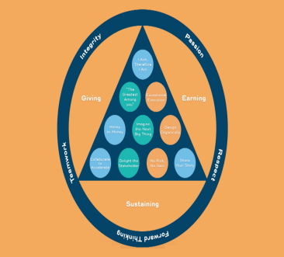nda; who does what?; craft a shared language and agenda; cement the agreement; give the credit*

**Chapter 7: Honey as Money**

*The “coalface of human suffering” in Zimbabwe; the psychology of scarcity; different flavors of honey; how constraint unleashes creativity; an experiment in imagination; the story of Peace One Day; honey is golden*

**Chapter 8: Delight the Stakeholder Let the institute know of your performances, trainings, workshops, and pay your dues. And shout for help when necessary, you are covered by the law that established the institute.**

**Chapter 9: No Risk,no gain. Don’t stay idle and expect manner from heaven, work hard, take risk, so that you can move forward in businesses and other undertakings.**

**10: Exceptional Execution**

*Make it simple; the execution dashboard; as in your life plan. executing to your life plan; execution is about culture; flexible control; happy competitiveness; your execution dashboard*

**Chapter 11: Share Your Story**

*The art of attentive listening is made valuable by practicing it; listening “head to head”; inspires you to perform. That’s what makes yu a professional, be a team Builder; tell your story to the world; storytelling platforms Social media; Contribute to problem solving events,initaiate actions to solve problems. Local, national, international as well. the power of live events*

**Chapter 12: Imagine the Next Big Thing Asses your achievements and see what next.**

## *Three questions and five criteria; how Petromin Express became the next big thing; building the next big thing in Saudi; if we build it, they will come; how to Educate Girls challenges the status quo; the power of “what if?”; raising the bar, be a servant leader; King Juan Carlos, servant leader; trust and respect; to delight the stakeholder, make things.*

Amr Al-Dabbagh, in july 2015 originated omnipreneurship**●**

**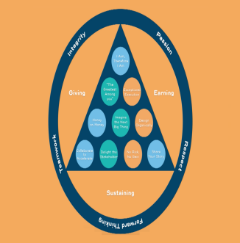**

“In short, you can road-test the omnipreneurial approach I present here in a wide variety of arenas. I have tested the principles, values, and rules of omnipreneurship with the greatest leaders around the world says Amr Al dabbagh, including well-known people in governments and in the academie settings as well as CEOs and leaders of NGOs who work every day to alleviate the suffering of children. he knows for a fact that omnipreneurship works to make a difference, in both small and enormous ways, every moment of every day.”Amr Al Dabbagh 2015.

The three main principles are:

*Risk and reward in a red-light district; why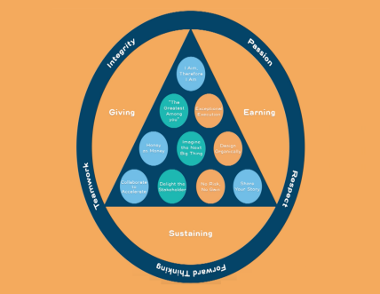 bad stuff happens; the importance of benchmarks and safety nets; the role of personal resilience; standing up to fear of failure; risk and the ten golden ru les*

**Personification.** As a professional (chartered member). Your **Principles, Values, and the Ten Golden Rules places you at a top level**

at its core, omnipreneurship is about principled leadership. For that reason, it’s powered and infused by a set of three guiding principles, five overarching values, and ten “golden rules.” These principles, values, and rules are values for intergrity, reputation, problem solver, and a God mediator on conflicts and that brings us to the six Guiding principles of the Institute. Which you have to personalize it and use it in your day today activities as a professional member. The six areas of the institutes cardinal functions principles .

* Conflict Resolution and Negotiation.
* Corporate Communication.
* Global Business Communication
* International Business Management.
* Creative Entrepreneurship.
* Diplomacy and Pratice.
* Leadership.

What the people want and what the leader wants

## Leaders manage the 5 “m”s-

## I.Men/women, ii. Money, iii.Machines,iv Materials,v.Methods and skills.

## Kinds of leaders: Traditional ii. Political, iii. Commercial, iii.Spiritual, iv.Academic vi enforcement. They come in as Elected, appointed, Nominated, investitured, inducted or ordained.

## Types of Leaders Autocratic (forceful, authoritative), Custodial (sluggish, passive, I don’t care type.), supportive(conscious of people welfare,have concern, smarter but not a hard liner, collegial (Team worker.& Partnership with members, self actualizing, no threats or coercive powers.).

## Leaders are planners, organizers, coordinators/controllers and are decision makers. They work with the concept principles theory of division of labour. They delegate responsibilities. to subordinates.

## *Human capital is intangible and elusive*. Meaning it Can not be manage by machine or what ever technology. Human capital is an asset and an investment. They can not be bought but can be compensated only. You can not buy loyalty.It takes a long time to develop an efficient resource persons for an organisation. In omnipreneurship. What leaders want and what members want

|  |  |  |
| --- | --- | --- |
| s/no | What leaders want. | What members want |
| 1 | Loyalty and fairness | Fairness and equity |
| 2 | support | Encouragement and Benefits |
| 3 | Cooperation | Pleasantness, safe work( job security) |
| 4 | Obedience | Advancement & promotion |
| 5 | Transparancy | Rights and Priviledges |
| 6 | Efficiency | Training and capacity building |
| 78. | ContributionsTime management and commitment | Recognition/Reward.Working materials/resources |

## Problem Solving Skills as a leader.

## Meaning: problem is a perplex situation that needs attention and solution, Steps in solving problems.

## Identify the problem .2.Identify the cause. 3. What are the critical factors. 4. what has to be changed ?. 5. What alternatives are available? 6. Evaluate the the alternatives.7. Select solution plan 8.what lessons can be learnt. 9. Keep record for future use.

## Meetings this concept is a method for identifying solutions to problems. For sharing information. For making decisions, policies, plans and for collating updates or reports.

## Meetings brings together personalities with there own unique goals,aspirations, desires, outlook in life and perceptions. It cost time and money to hold meetings, so it’s a serious business..

## The one that cost is formal meeting and the one that does not cost a price Is informal.

## To call a meeting: 1. Define the problem. 2.Define their limits.3 provide any information. 4.Prepare the Agenda(content for deliberation) 5.Budget the materials needed for the meeting. 6. Chair the meeting or delegate. 7 Get the solutions accepted to all. 8 over rule(veto) conflicting discuss if necessary. 9.implement ation of solution assign task to members or committee 10. Follow up, supervise and ensure it is done. 11 Evaluate members reaction to the achievement recorded.. 12 Keep Recordsfor the future. As a professional in an meeting watch this PITFALLS features in a meeting, self serving rules and group serving rules

## Improper setting

## Hidden Agenda

## The talkative .

## The competitive spirit minded.

## The saboteurs.

|  |  |  |
| --- | --- | --- |
| s/no | Self serving rules | Group serving rules |
| 1 | Attention getting personality(ies) | Coordinating personality(ies) |
| 2 | Blocking (interrupting) personality(ies). | Fortifying personality(ies) |
| 3 | Criticising personality(ies). | initaiting personality(ies) |
| 4 | Dominating personality(ies). | orienting personality(ies) |
| 5 | Withdrowing personality(ies) | Research optimiser |

## Micro-metrics of Corruption to watch as professional certified member of the institute and as a leader. The 5 “P”s

## Corrupt Policies:

## Corrupt Plans:

## Corrupt Programmes:

## Corrupt Projects.

## Corrupt Practices:

## Conclusion..

## REFERENCES:

1. The professionals point of view. Advance excerpt, [Omnipreneurship](https://novoed.com/philanthropy-university-leadership/attachments/85329/view" \t "_blank)by Amr Al-Dabbagh JULY 2015.
2. [7 Core Values Statements that Inspire](http://fortune.com/2015/03/13/company-slogans/) by Holly Lebowitz Rossi

## I WISH YOU THE BEST OF LUCK , AND PRATICE OMINIPRENEURSHIP FOR YOUR GROWTH AND SUCCESS IN LIFE..

## *AGRIH DAUDA SUKUKUM* .(*FCIGCD)* .

## *SOCIAL SECTOR LEADER* .

## CERTIFIED BY PHILANTROPHY UNIVERSITY. JANUARY, 2016 .

## ©MAY 2016 .